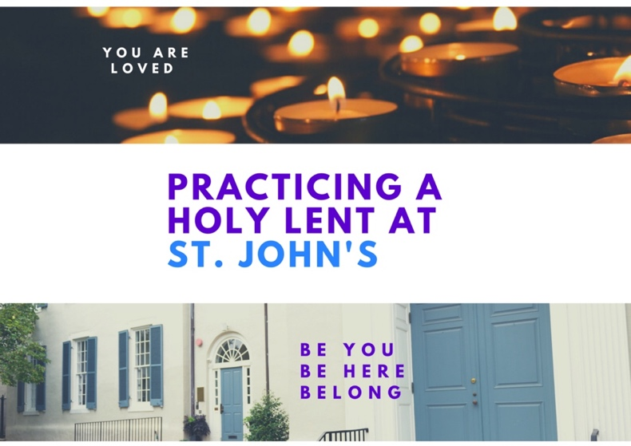

Deepen Your Faith During Lent! (And also engage with people!) For all of these events the links come out in our weekly email. Contact Kurt @ stjohnsgeorgetown.org or 202-338-1796 to get our weekly email or to get one of these links!

Monday and Friday mornings at 8:30 – Zoom Morning Prayer with St. John’s and Christ Church, Georgetown. Come any or every Monday or Friday – no sign up required! Join this ancient service of prayer to start your day, grounded in prayer and Scripture. You can also sign up to submit a reading or to be one of the leaders.

Tuesday evenings at 5:30 – Zoom Centering Prayer and Eucharist. This quiet, candlelit service has been going strong at St. John’s for more than 20 years, but this year, it has moved from the Chapel to the internet.

Wednesday evenings at 7:00, starting February 24th – Do you want to go deeper into your faith? To ask hard questions? To understand how God has worked, and is working, in your life? In this six-week small group, you will share your story and explore what makes us human and gives our lives meaning. Sessions include prayer, Bible Study, and reflection on God’s work in our lives and the world. Want to know more? Click here to learn more about this program created by the Episcopal Diocese of Colorado! Email Kurt to register or with questions!

Fridays at Noon – Brown Bag Bible Study! Grab your lunch and join a small group for a quick (no more than 1 hour) exploration of the coming Sunday's readings. Come one, or every Friday!

Two Saturday mornings, March 6th and 13th 10:00-11:30 – In this time of Covid, the reality of death is more openly discussed. But for some, the prospect of being with someone who is dying can bring up feelings of inadequacy and fear, sometimes so strong that they find excuses to stay away. What do dying people need? What gets in their way? And what gets in our way? How can we find a quiet place within ourselves to enable us to be present to the dying person as a source of comfort? Join St. John’s parishioner and Palliative Care Chaplain Joan Maxwell as she explores these vital questions in a two-part zoom series. Click here for the link to register.

Sunday evenings in March – Spiritual Practices Workshop. We will explore and practice a rich variety of ways for people to pray, meditate, study Scripture, etc. Spiritual practices have kept us grounded and sane during the past year! Find practices that work for YOU, and we will continue into Easter if there is interest.

